18.1-3) page 323
Aggregate Method. Since the total cost of the n operations is
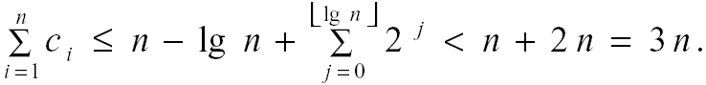
Therefore, the amortized cost of a single operation is 3 = O(1).

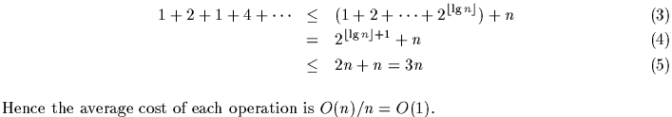
18.2-1) page 325
Assign two credits to each push-operation and 2 credits to each pop-operation. One credit is used to complete the given operation; the other credit is stored with the stack. After k operations the stack has accumulated k credits. These k credits can be used to pay for making the backup copy of the stack (note that we need O(k) credits to make a k-size copy). Thus, the worst-case time for n operations, equal to the number of credits used, is O(n).
18.2-3) page 325
We need to store some more credits so that they're available when we have to reset the counter. The text provides the hint that we should keep a pointer to the high-order 1. Using this pointer to tell us where the counter ends, the cost to reset the counter is equal to the current number of digits used by the counter. We use 3 credits per INCREMENT operation and 1 credit per RESET operation. The first two INCREMENT credits are used, as in the text, to set a bit to 1 and to store a credit with this 1 (this credit is used during later increments when the 1-bit is changed to a 0-bit). The remaining credit is stored with the counter. The number of credits stored with the counter is always equal to the current value of the counter (which is considerably more than the length of the counter --- the amount of credit that we really need to do a reset). Thus there are always sufficiently many credits available (stored with the counter) to accomplish a RESET-operation. Since O(1) credits are charged for each operation and since there are always enough credits available to accomplish these operations, the total time for n operations is O(n).
